|  |  |  |
| --- | --- | --- |
| **No.** | **Title** | **Page No.** |
| **1** | **Project Profile** | 02 |
|  | 1.1 Student Profile | 03 |
|  | 1.2 Project Definition | 06 |
|  | 1.3 System Specification | 07 |
| **2** | **Tools/ Platform** | 08 |
|  | 2.1 Front End Tools | 08 |
|  | 2.2 Back End Tools | 14 |
| **3** | **Analysis** | 17 |
|  | 3.1 About Existing System | 18 |
|  | 3.2 Limitation of existing system | 19 |
|  | 3.3 Advantages of proposed system | 20 |
|  | 3.4 Feasibility Study | 21 |
|  | 3.5 Use Case Diagram | 22 |
|  | 3.6 DFD (Module wise) | 24 |
| **4** | **Design** | 26 |
|  | 4.1 E –R Diagram | 27 |
|  | 4.2 Class Diagram | 28 |
|  | 4.3 Activity Diagram | 29 |
|  | 4.4 Sequence Diagram | 32 |
|  | 4.5 Data Dictionary | 33 |
| **5** | **Testing and Implementation** | 36 |
|  | 5.1 Input Screen | 37 |
|  | 5.2 Screen Layout | 37 |
|  | 5.3 Sample Code | 47 |
| **6** | **Limitations and Future Enhancement** | 60 |
| **7** | **Bibliography** | 61 |

Chapter-1

PROJECT PROFILE

* 1. **Student Profile**
  2. **Project Definition**
  3. **System Specification**

|  |  |  |
| --- | --- | --- |
| Project Profile | | |
| next.jpg | **Enrollment No.** | 03052000397  03052000347 |
| next.jpg | **Student Name** | Arpitkumar Vadariya  Jay Bhalodiya |
| next.jpg | **Project Title** | Hair Studio Parlor Management System. |
| next.jpg | **Project Type** | Web Site |
| next.jpg | **Tools & Technology** | HTML, CSS, JavaScript, PHP, MYSQL |
| next.jpg | **Front – End** | HTML, CSS, JavaScript, PHP |
| next.jpg | **Back – End** | MYSQL |
| next.jpg | **Team Member** | 2 |

* 1. **Student Profile**

|  |  |  |
| --- | --- | --- |
| Name | **:** | Arpitkumar Vadariya |
| Enrolment No. | : | 03052000397 |
| Student Id. | : | 2020004280 |
| Mobile No: |  | 7226058760 |
| Email Id. | : | [arpit092vadariya@gmail.com](mailto:arpit092vadariya@gmail.com) |
| Guided By | : | Prof. Rinku Chavda  Dr. Subhash College of Computer Science, Junagadh (362001) |
| Title of the Project Date of Submission | :  : | Hair Studio  27.09.2022 |

|  |  |  |
| --- | --- | --- |
| Name | **:** | Jay Bhalodiya |
| Enrolment No. | : | 03052000347 |
| Student Id. | : | 2020004230 |
| Mobile No |  | 6352176794 |
| Email Id. | : | [jaybhalodiya102@gmail.com](mailto:jaybhalodiya102@gmail.com) |
| Guided By | : | Prof. Rinku Chavda  Dr. Subhash College of Computer Science, Junagadh (362001) |
| Title of the Project Date of Submission | :  : | Hair Studio  27.09.2022 |

**­**

* 1. **Project ­­­­Definition: -**
* Hair studio is Beauty Parlor and Salon.
* This is web site for appointment scheduling functionality.
* It provides interface between salon and clients.
* In current time all things become online like shopping study etc.­­
* So, this website can help customer and salon owner using online appointment booking.
* Customers can book appointment before his/her event to look good in event.
* Brides and Grooms can make appointment for his/her wedding to look good in wedding, Reception or Engagement.
  1. **System Specification (H/W, S/W, Network):-**

A . **Hardware Specification**

* Intel-core-i3/Intel-core-i5 and Higher Prosessor
* 512 Mb Ram
* 1 GB Free Hard-Drive Space

**A . Software Specification**

* PHP (Font-end)
* HTML
* JavaScript
* MS Word 97 or later
* Visual Studio Code
* Web Browser: Microsoft Internet Explorer, Mozilla, Google Chrome or later
* MySQL Server (back-end)
* Operating System: Windows 10 / Windows 7/ Windows XP

Chapter-2

TOOLS / PLATFORM

* 1. **Front End Tools**
  2. **Back End Tools**
  3. **Front End Tools**
* **HTML**



* The **HyperText Markup Language** or **HTML** is the standard [markup language](https://en.wikipedia.org/wiki/Markup_language) for documents designed to be displayed in a [web browser](https://en.wikipedia.org/wiki/Web_browser).
* HTML (Hypertext Markup Language) is the only markup language for creating web pages. It provides some titles, headings, paragraphs, lists, tables, embedded images, etc., to describe the structure of text-based and multimedia information in HTML documents.
* HTML is a [markup language](https://en.wikipedia.org/wiki/Markup_language) that [web browsers](https://en.wikipedia.org/wiki/Web_browser) use to interpret and [compose](https://en.wikipedia.org/wiki/Typesetting) text, images, and other material into visual or audible web pages
* HTML is a [markup language](https://en.wikipedia.org/wiki/Markup_language) that [web browsers](https://en.wikipedia.org/wiki/Web_browser) use to interpret and [compose](https://en.wikipedia.org/wiki/Typesetting) text, images, and other material into visual or audible web pages.
* The First Version Of HTMLWas Written BY **Tim-Burners-Lee**
* **October 28, 2014** HTML5 was published as a W3C Recommendation
* **CSS**



* **Cascading Style Sheets** (**CSS**) is a [style sheet language](https://en.wikipedia.org/wiki/Style_sheet_language) used for describing the [presentation](https://en.wikipedia.org/wiki/Presentation_semantics) of a document written in a [markup language](https://en.wikipedia.org/wiki/Markup_language) such as [HTML](https://en.wikipedia.org/wiki/HTML) or [XML](https://en.wikipedia.org/wiki/XML) (including XML dialects such as [SVG](https://en.wikipedia.org/wiki/Scalable_Vector_Graphics), [MathML](https://en.wikipedia.org/wiki/MathML) or [XHTML](https://en.wikipedia.org/wiki/XHTML)) CSS is a cornerstone technology of the [World Wide Web](https://en.wikipedia.org/wiki/World_Wide_Web), alongside HTML and [JavaScript](https://en.wikipedia.org/wiki/JavaScript).
* CSS is said to as the cornerstone design tool of the World Wide Web along with HTML and JavaScript
* CSS level 1, published on 17 December 1996. [Håkon Wium Lie](https://en.wikipedia.org/wiki/H%C3%A5kon_Wium_Lie) and [Bert Bos](https://en.wikipedia.org/wiki/Bert_Bos) are credited as the original developers
* **Java-Script**



* JavaScript  often abbreviated to JS, is a [programming language](https://en.wikipedia.org/wiki/Programming_language) that is one of the core technologies of the [World Wide Web](https://en.wikipedia.org/wiki/World_Wide_Web), alongside [HTML](https://en.wikipedia.org/wiki/HTML) and [CSS](https://en.wikipedia.org/wiki/CSS).As of 2022, 98% of [websites](https://en.wikipedia.org/wiki/Website) use JavaScript on the [client](https://en.wikipedia.org/wiki/Client_(computing)) side for [webpage](https://en.wikipedia.org/wiki/Web_page) behavior, often incorporating third-party [libraries](https://en.wikipedia.org/wiki/Library_(computing)).[All major [web browsers](https://en.wikipedia.org/wiki/Web_browser) have a dedicated [JavaScript engine](https://en.wikipedia.org/wiki/JavaScript_engine) to execute the [code](https://en.wikipedia.org/wiki/Source_code) on [users](https://en.wikipedia.org/wiki/User_(computing))' devices..
* JavaScript Was Invented By Brendan Eich in 1995

It Was Developed For Netscape 2, became the ECMA-262 Standard in 1997

* **PHP**
* **WHAT IS PHP :**



* PHP was developed by Rasmus Lerdorf . It is a freeware .
* It is also a weakly typed, freeform language.
* PHP has since evolved into a powerful server-side markup language with syntax that resembles a mix between Perl and C.
* PHP is a server-side scripting language designed specifically for the Web.
* Within an HTML page, we can embed PHP code that will be executed each time the page is visited.
* HTML generatesthe web page with the static text and images.
* However the need evolved for dynamic web basedapplication, mostly involving database usage. These dynamic usages are facilated by PHP.
* Other tasks that PHP is especially good at are database access,

 disk access, networking and textmanipulation.

* PHP is an excellent alternative to such similar programming solutions as Microsoft's proprietary scripting engine ASP and Allaire's rather expensive ColdFusion.
* As mentioned before,PHP is a cross-platform language.

**FEATURES OF PHP :**

* The main features of php is; it is open source scripting language so you can free download this and use.
* PHP is a server site scripting language. It is open source scripting language.
* It is widely used all over the world. It is faster than other scripting language. Some important features of php are given below;
* 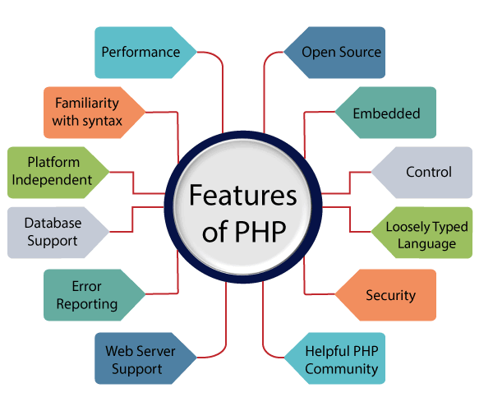

**History of PHP :**

* PHP was conceived sometime in the fall of 1994 by [Rasmus Lerdorf](mailto:rasmus@php.net).
* Early non-released versions were used on his home page to keep track of who was looking at his online resume.
* The first version used by others was available sometime in early 1995 and was known as the Personal Home Page Tools.
* It consisted of a very simplistic parser engine that only understood a few special macros and a number of utilities that were in common use on home pages back then.
* A guestbook, a counter and some other stuff. The parser was rewritten in mid-1995 and named PHP/FI Version 2.
* The FI came from another package Rasmus had written which interpreted html form data. He combined the Personal Home Page tools scripts with the Form Interpreter and added mSQL support and PHP/FI was born. PHP/FI grew at an amazing pace and people started contributing code to it.
* It is difficult to give any hard statistics, but it is estimated that by late 1996 PHP/FI was in use on at least 15,000 web sites around the world
* By mid-1997 this number had grown to over 50,000. Mid-1997 also saw a change in the development of PHP.
* It changed from being Rasmus' own pet project that a handful of people had contributed to, to being a much more organized team effort.
* The parser was rewritten from scratch by Zeev Suraski and Andi Gutmans and this new parser formed the basis for PHP Version 3.
* A lot of the utility code from PHP/FI was ported over to PHP3 and a lot of it was completely rewritten.
* Today (end-1999) either PHP/FI or PHP3 ships with a number of commercial products such as C2's StrongHold web server and RedHat Linux.
* A conservative estimate based on an extrapolation from numbers provided by [NetCraft](http://www.netcraft.com/) (see also [Netcraft Web Server Survey](http://www.netcraft.com/survey/)) would be that PHP is in use on over 1,000,000 sites around the world.
* To put that in perspective, that is more sites than run Netscape's flagship Enterprise server on the Internet.
* Also as of this writing, work is underway on the next generation of PHP, which will utilize the powerful [Zend](http://www.zend.com/) scripting engine to deliver higher performance, and will also support running under webservers other than Apache as a native server module.

.

* 1. **Backend Tools**
* **MySQL**    

MySQL is currently the most popular database management system software used for managing the relational database. It is open-source database software, which is supported by Oracle Company. It is fast, scalable, and easy to use database management system in comparison with Microsoft SQL Server and Oracle Database. It is commonly used in conjunction with [PHP](https://www.javatpoint.com/php-tutorial) scripts for creating powerful and dynamic server-side or web-based enterprise applications.

It is developed, marketed, and supported by **MySQL AB, a Swedish company**, and written in [C programming language](https://www.javatpoint.com/c-programming-language-tutorial) and [C++ programming language](https://www.javatpoint.com/cpp-tutorial). The official pronunciation of MySQL is not the My Sequel; it is ***My Ess Que Ell***. However, you can pronounce it in your way. Many small and big comanies use MySQL. MySQL supports many Operating Systems like [Windows](https://www.javatpoint.com/windows), [Linux](https://www.javatpoint.com/linux-tutorial), MacOS, etc. with C, C++, and [Java languages](https://www.javatpoint.com/java-tutorial).

MySQL is a [Relational Database Management System](https://www.javatpoint.com/what-is-rdbms) (RDBMS) software that provides many things, which are as follows:

* It allows us to implement database operations on tables, rows, columns, and indexes.
* It defines the database relationship in the form of tables (collection of rows and columns), also known as relations.
* It provides the Referential Integrity between rows or columns of various tables.
* It allows us to updates the table indexes automatically.
* It uses many SQL queries and combines useful information from multiple tables for the end-users.

## History of MySQL:

The project of MySQL was started in 1979 when MySQL's inventor **Michael Widenius** developed an in-house database tool called **UNIREG** for managing databases. After that, UNIREG has been rewritten in several different languages and extended to handle big databases. After some time, Michael Widenius contacted **David Hughes**, the author of mSQL, to see if Hughes would be interested in connecting mSQL to UNIREG's B+ ISAM handler to provide indexing to mSQL. That's the way MySQL came into existence.

Chapter-3

ANALYSIS

**3.1 About Existing System**

**3.2 Advantages of proposed system**

**3.3 Feasibility Study**

**3.4 Use Case Diagram**

**3.5 DFD (Module wise)**

* 1. **Existing System:**
* Hair Studio is a service-oriented establishment in which women and men receive treatment to increase their beauty. Skin care, facial make up, hair nourishment and model hair cutting are the most important nourishing activities of a beauty parlor. The use of machinery, ayurvedic formulations and approved synthetic chemicals and medicines vary from person to person as per need. In present project the provision of different beauty therapy is present with use of limited amount of machinery.
* The beauty therapy is basically classified in items like hair cutting, nourishment of hair, dyeing of hair, prevention of hair fall, facial, treatment of pimples, pedicure etc. Facial itself is a very vast subject in which eye brow shaping, cleaning of face to remove dirt, application of cream and herbal extracts to nullify the aging and to cover wrinkles etc. As per the demand, special application of natural color to increase the beauty or aesthetic sense, use of eye pencil in eyebrow, eye lashes also measure the quality of the service provided by the parlor. Hair coloring with natural herbs, nail shaping, colorings, pedicure, manicure are also some additional service activities from which the centre earns good profit as well as good name and fame.
* All these activities are performed by experienced beauticians in respective fields. The authority should appoint exports in facial activities, in hair treatment, pimple treatment and pedicure, manicure, separately to improve the quality of servicing and to create confidence among the new customers. The technique of application of dye to hair, natural herbal extracts colors to chicks are all scientifically regulated to impart best result. It also varies from training institute to training institute. The aim is the customer’s satisfaction.
  1. **Limitations of existing system:**
* Not Providing Online Service
* Online Booking Is Not Providing
* Not Handle Heavy Load
* Not User-Friendly
* UI Is Older
* Some Changes On The Requirements
* Some Time Crashed
  1. **Advantages and Disadvantages**

**Advantages:**

* Providing direct information.
* You can book any time 24*7.
* Booking: Scheduling Date
* Cancel Appointment.
* Buy Package of Services**.**

**Disadvantages:**

* Online payment is not available.
* Mandatory sign-up needed for the Client.
* Only read module for viewer.
* Different rights for actors.
  1. **Feasibility Study**
* After implementing the Parlor Management System project and investigating and analyzing all existing or required features of the System, the next task is to carry out a feasibility study. All projects can be run with unlimited resources and infinite time, and the feasibility study involves considering all possible ways to provide a solution to a given problem. The proposed solution should meet all user requirements and be flexible enough to adapt to future changes based on future needs quickly.

### Economic Feasibility

* This is an essential aspect to consider when developing a project. We chose the technology based on the lowest possible cost factors.
* The organization must bear all hardware and software costs.
* Overall, it is estimated that the benefits that an organization will get from the proposed System will outweigh the initial and subsequent costs

### Technical Feasibility

* This included investigating features, performance, and limitations that could affect the ability to achieve a tolerable system. To demonstrate this proof of concept, we have explored all the features provided by the System as described in the System. Requirements Specification (SRS), and everything is possible with the different types of front-end and backend platforms. I confirmed that there is.
* Operational feasibility Undoubtedly, the proposed System is completely GUI-based, very user-friendly, and all inputs are self-explanatory to the layman. In addition, proper training is provided to convey the essence of the System to the user, and the user can become accustomed to the new System. Our customers are comfortable and happy with our research because the System has reduced stress and strain.
  1. **Use Case Diagram**

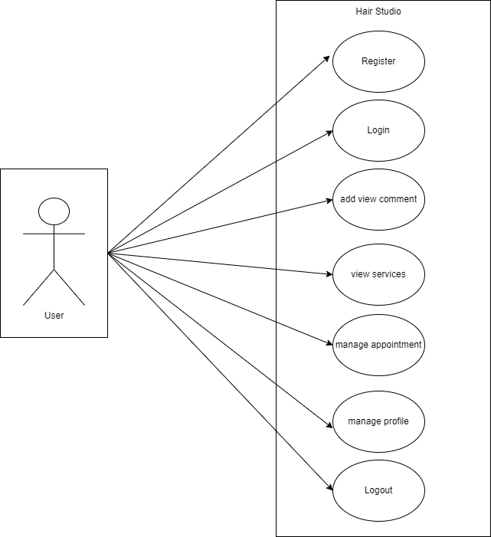

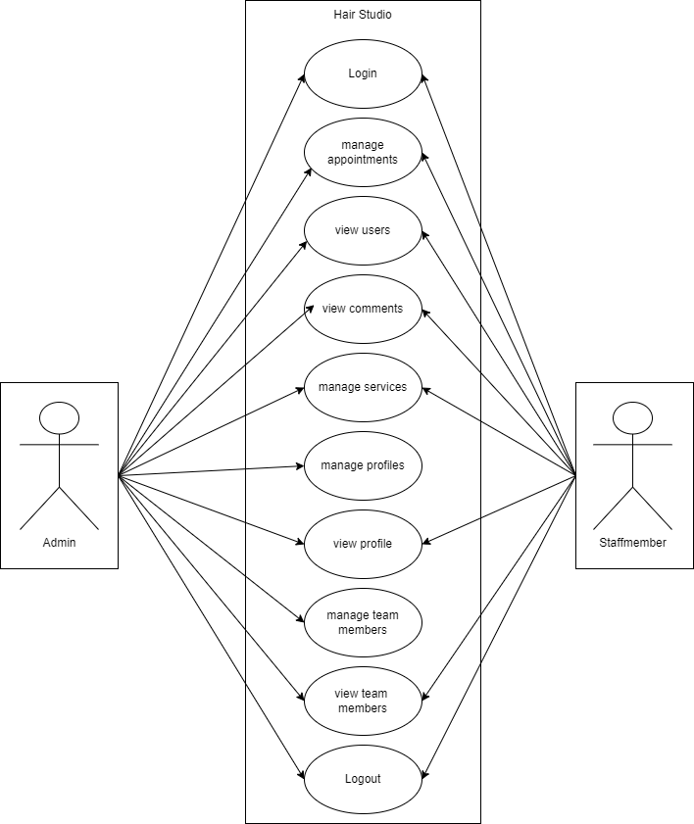

**3.5 Data Flow Diagram:**

* **user DFD:**

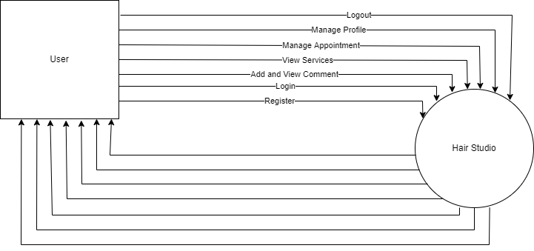

* **staffmember DFD:**

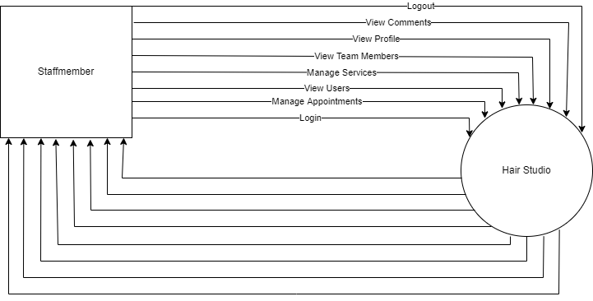

* **admin DFD:**

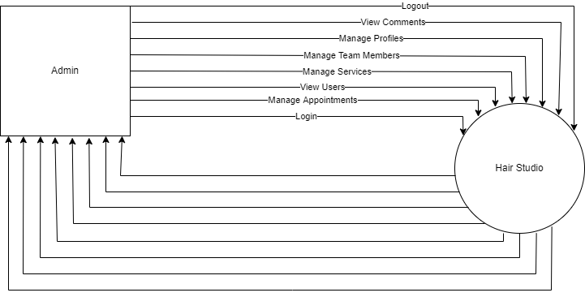

Chapter-4

DESIGN

**4.1 E –R Diagram**

**4.2 Class Diagram**

**4.3 Activity Diagram**

**4.4 Sequence Diagram**

**4.5 Data Dictionary**

**4.1 E –R Diagram:**

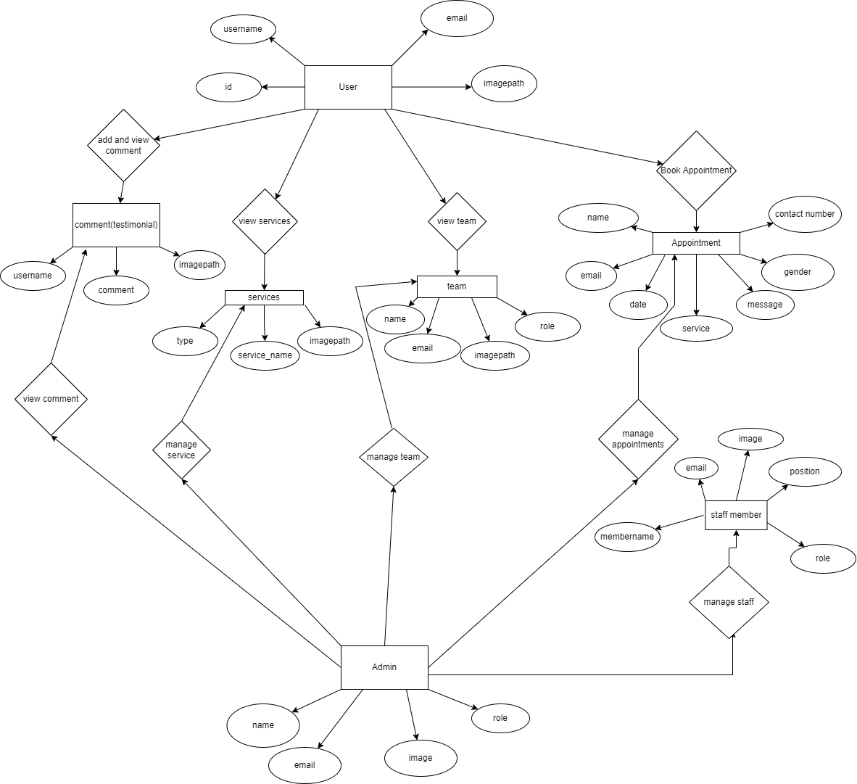

**4.2 Class Diagram:**

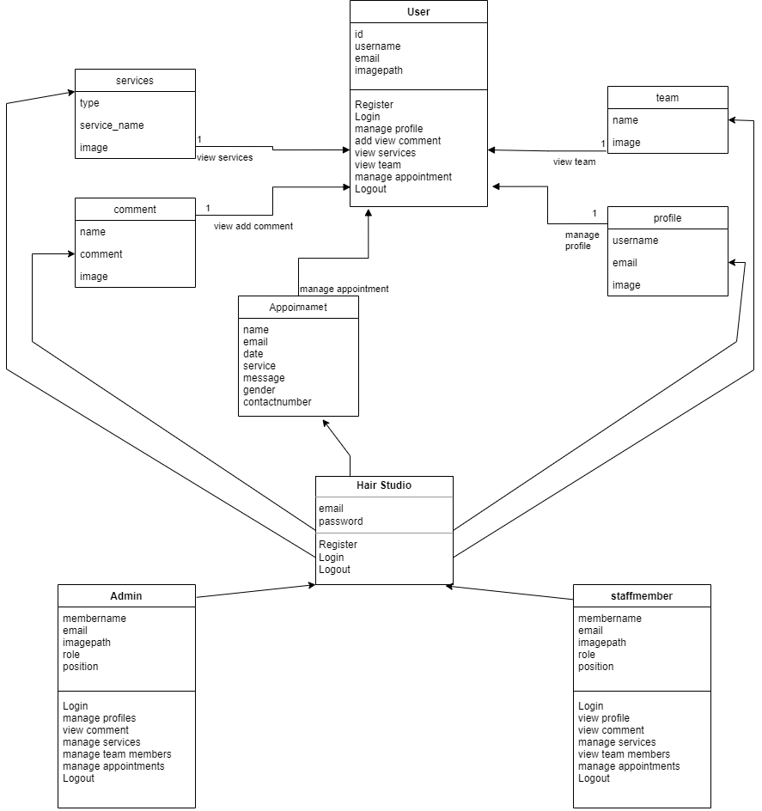

**4.3 Activity Diagram:**

* **user activity diagram:**

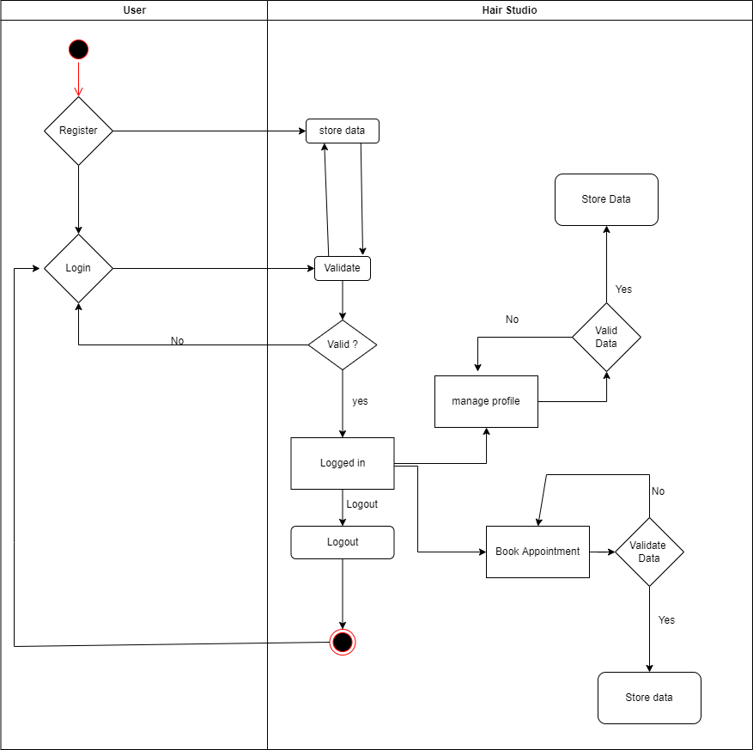

* **staffmember activity diagram:**

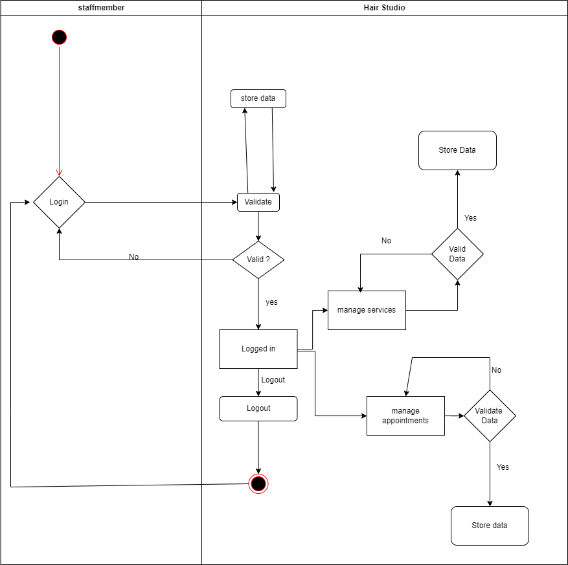

* **admin activity diagram:**

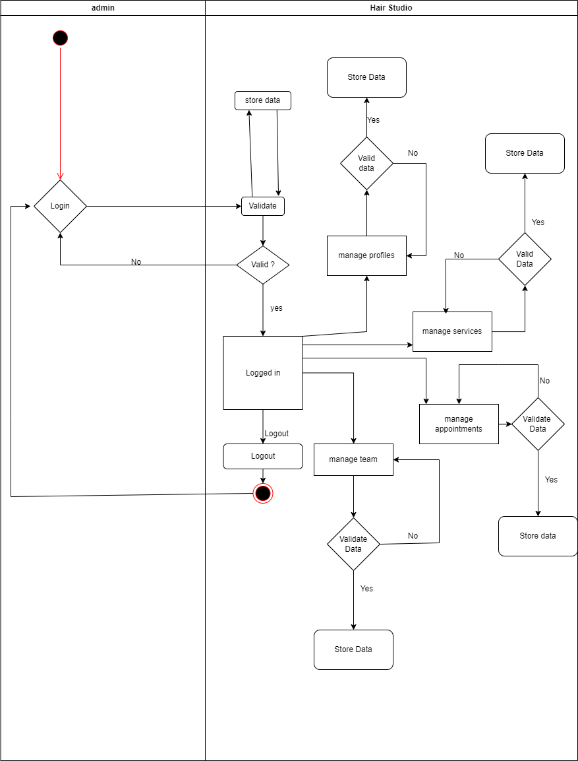

**4.4 Sequence Diagram:**

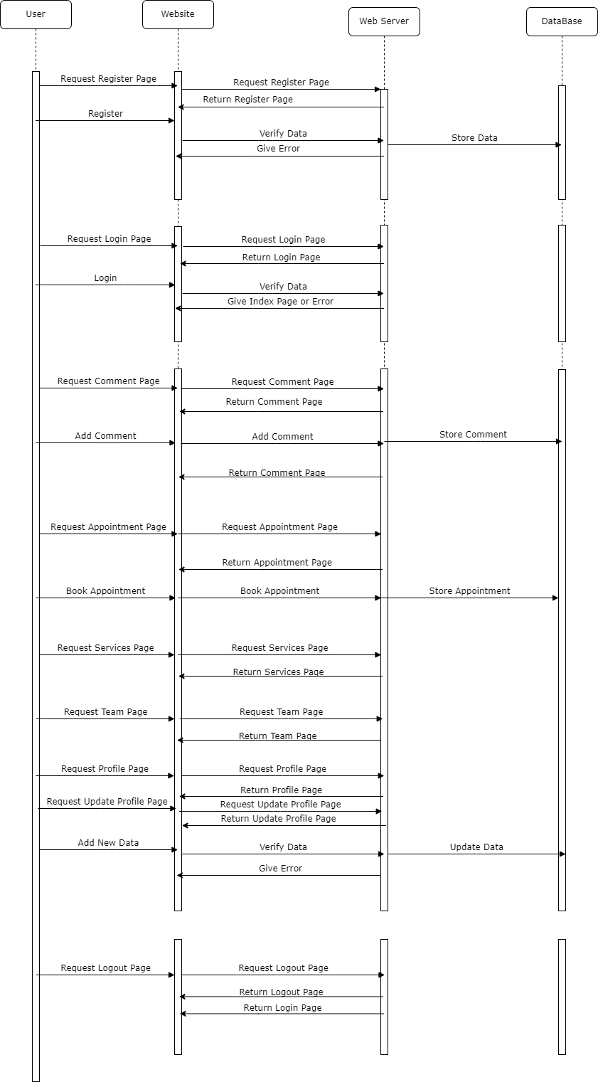

**4.5 Data Dictionary:**

* **Appointments:**

|  |  |  |  |
| --- | --- | --- | --- |
| No | Name | Type | Not Null |
| 1 | Name | Varchar | - |
| 2 | Email | Varchar | - |
| 3 | Date | Varchar | - |
| 4 | Service | Varchar | - |
| 5 | Message | Varchar | - |
| 6 | Gender | Varchar | - |
| 7 | Contact number | Varchar | - |
| 8 | Approved | Integer | - |

* **Services:**

|  |  |  |  |
| --- | --- | --- | --- |
| No | Name | Type | Not null |
| 1 | Type | Varchar | - |
| 2 | Service_name | Varchar | - |
| 3 | image | Varchar | - |

* + **Team:**

|  |  |  |  |
| --- | --- | --- | --- |
| No | Name | Type | Not null |
| 1 | Name | Varchar | - |
| 2 | Email | Varchar | - |
| 3 | Role | Varchar | - |
| 4 | Image | Varchar | - |

* **Testimonials:**

|  |  |  |  |
| --- | --- | --- | --- |
| No | Name | Type | Not null |
| 1 | username | Varchar | - |
| 2 | Comment | Varchar | - |
| 3 | imagepath | Varchar | - |

* **Userdata:**

|  |  |  |  |
| --- | --- | --- | --- |
| No | Name | Type | Not null |
| 1 | id | Integer | Primary Key |
| 2 | username | Varchar | - |
| 3 | Email | Varchar | - |
| 4 | Password | Varchar | - |
| 5 | Image | Varchar | - |

* **Staff:**

|  |  |  |  |
| --- | --- | --- | --- |
| No | Name | Type | Not null |
| 1 | membername | Varchar | - |
| 2 | Email | Varchar | Primary Key |
| 3 | Password | Varchar | - |
| 4 | role | Varchar | - |
| 5 | Position | Varchar | - |
| 6 | Image | Varchar | - |

Chapter-5

**Testing and Implementation**

**5.1 Input Screen**

**5.2 Screen Layout**

**5.3 Sample Code**

**5.1 Input Screen / 5.2 Screen Layout**

**User Register Page:**

* + 1. 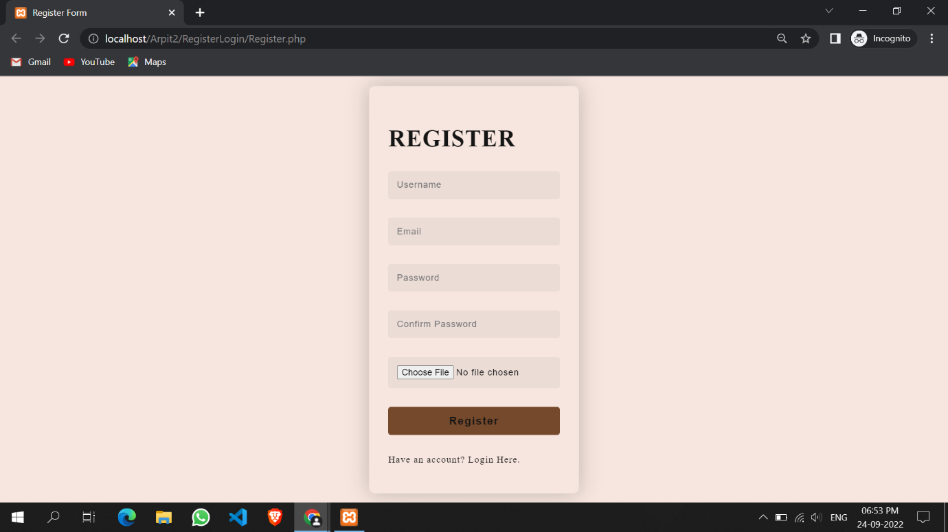
    2. **User Login Page:**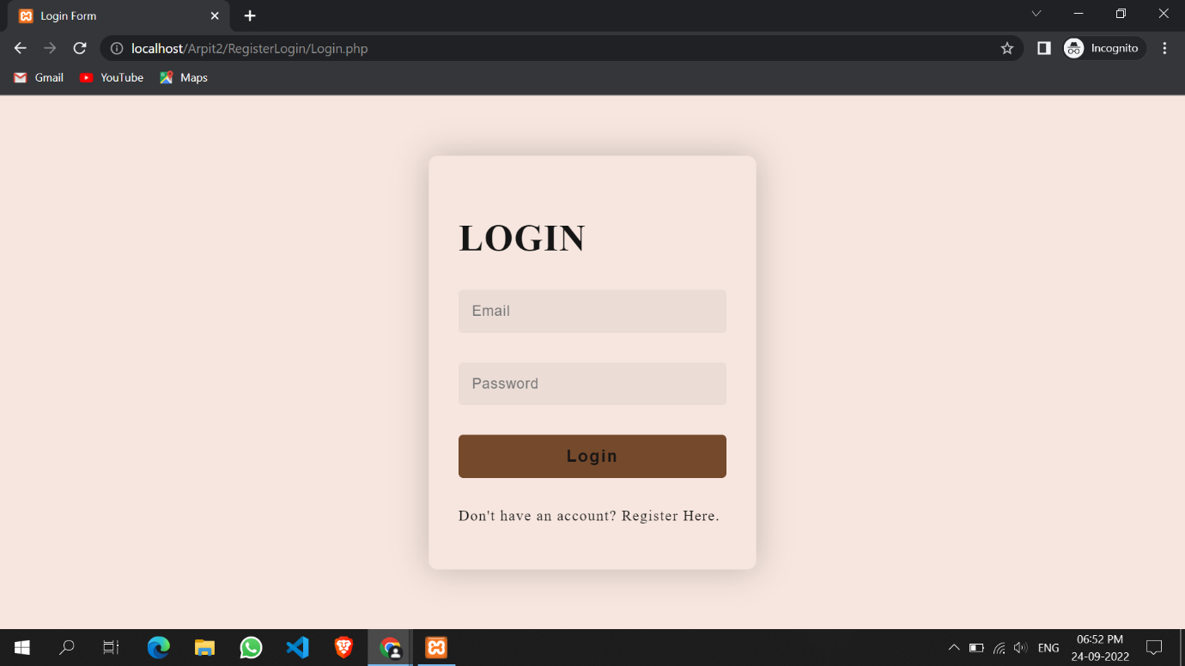
    3. **Home Page Screen:**
    4. 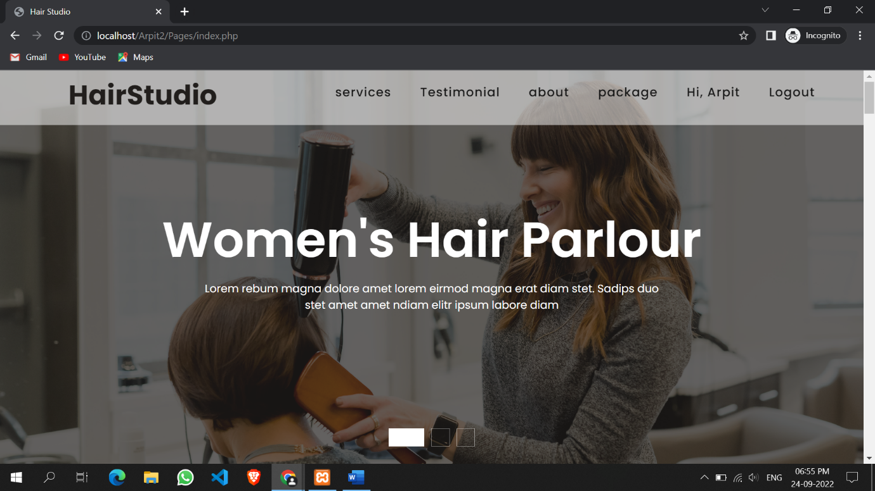
    5. **About Us:**
    6. 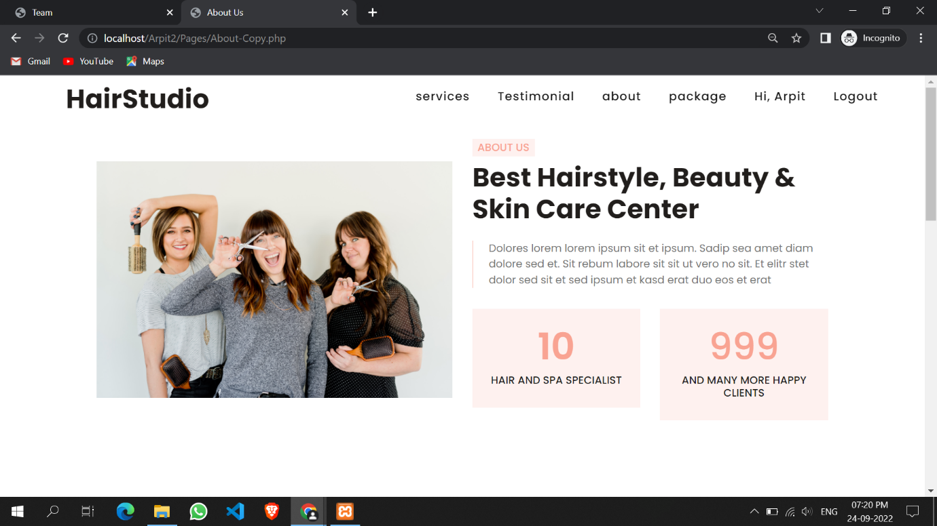
    7. **Testimonials:**
    8. 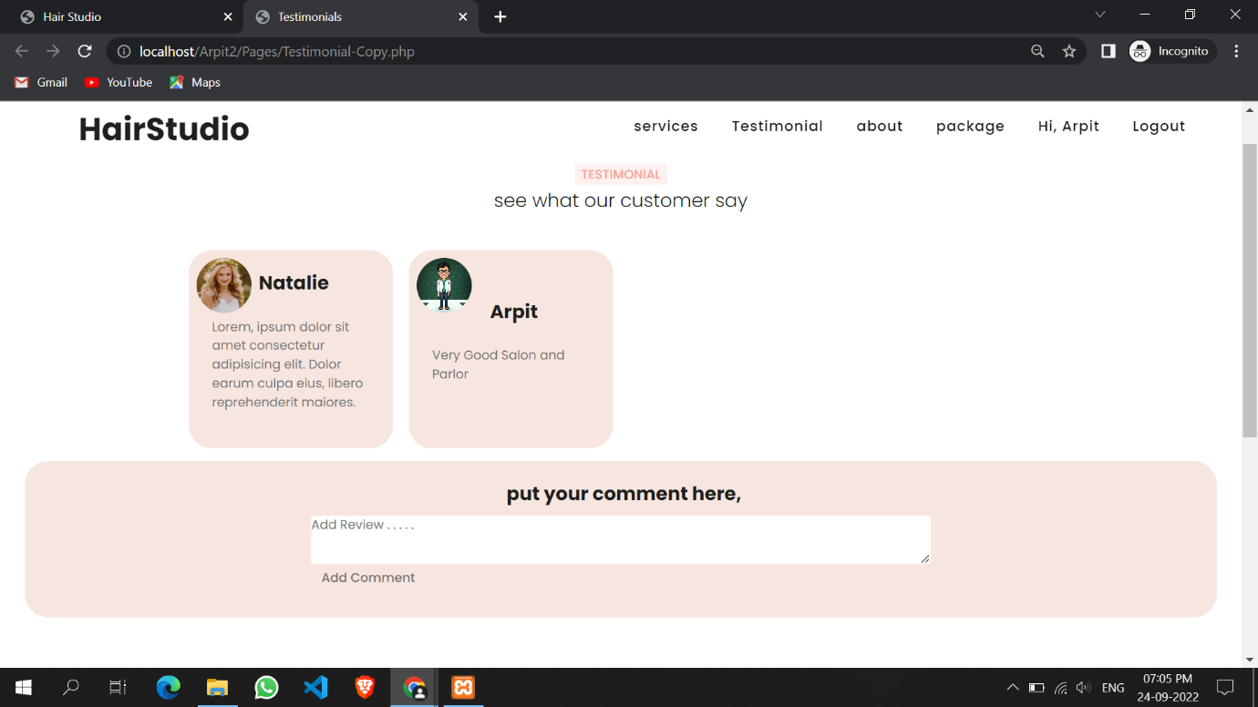
    9. **Profile Page:**
    10. 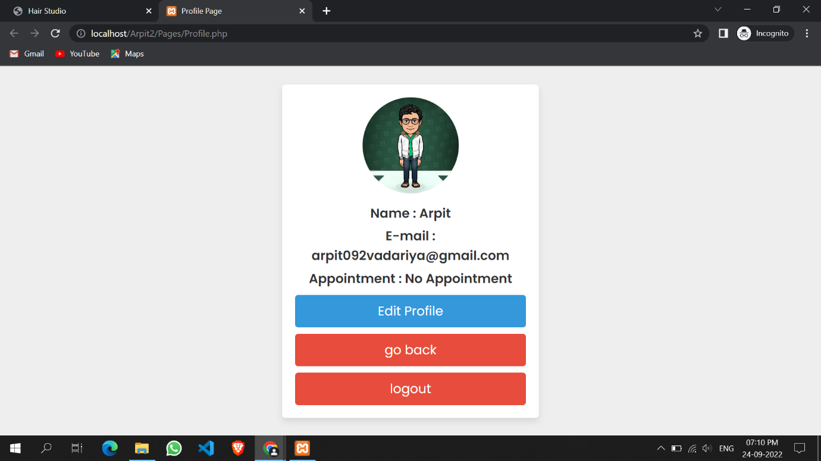
    11. **Profile Edit:**
    12. 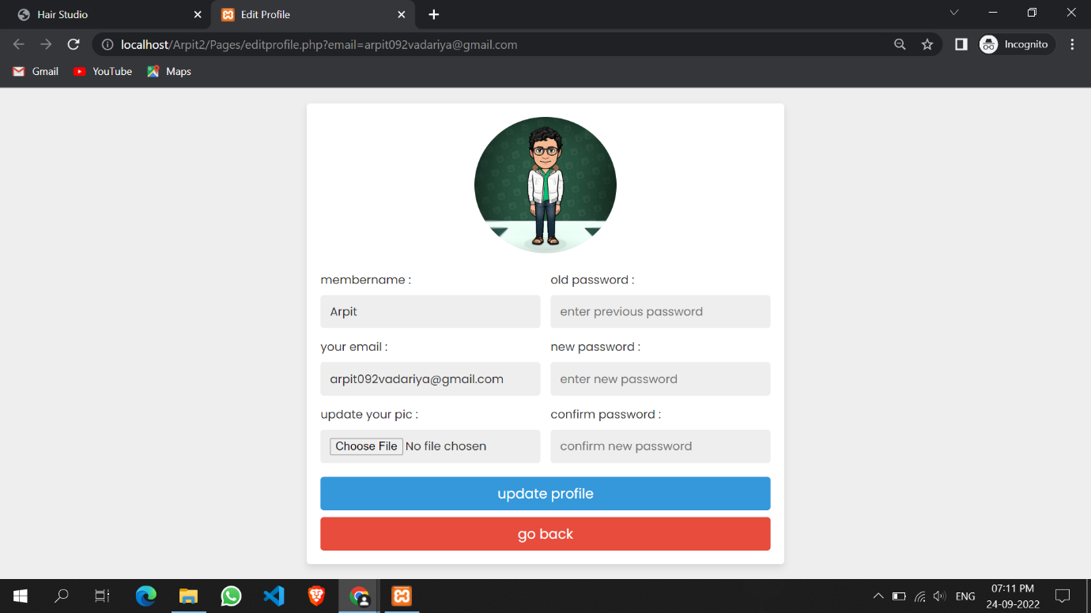
    13. **Packages:**
    14. 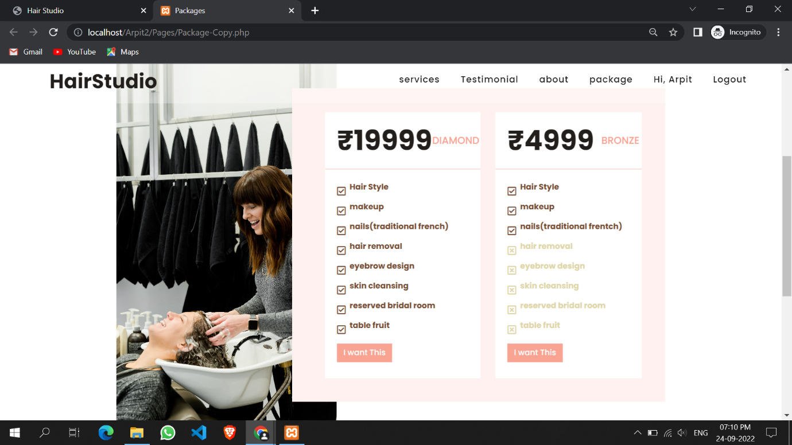
  1. **Team:**
  2. 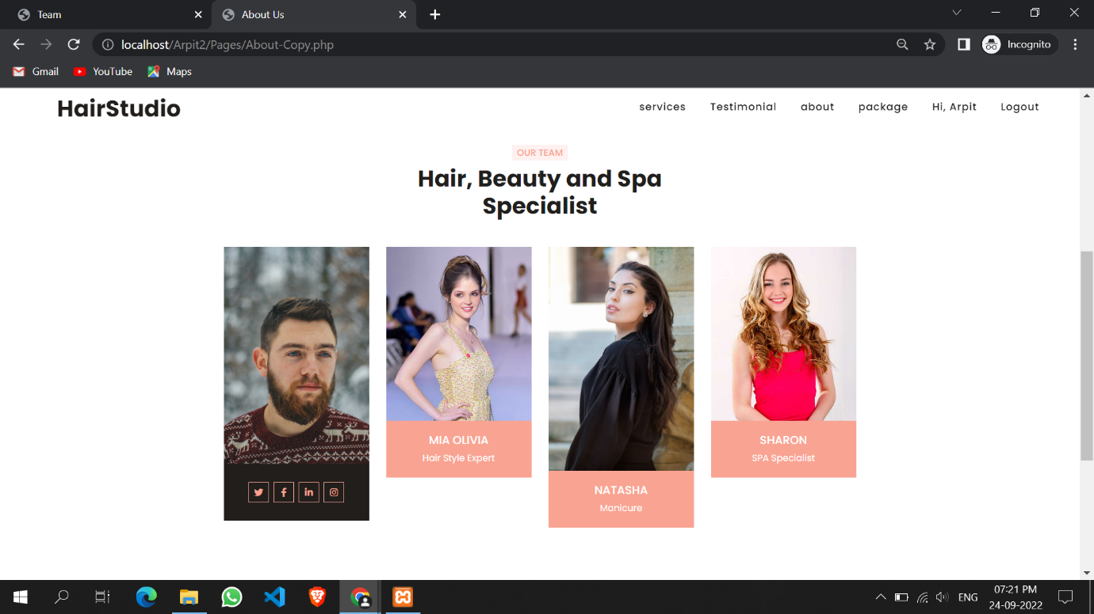
  3. **Services:**
  4. 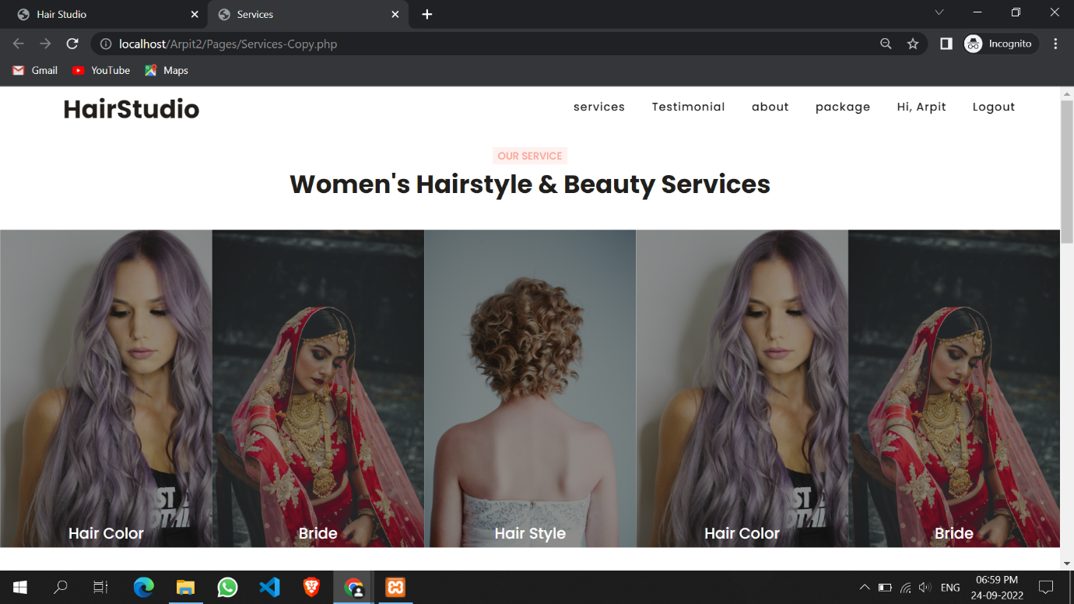
  5. **Admin Login:**
  6. 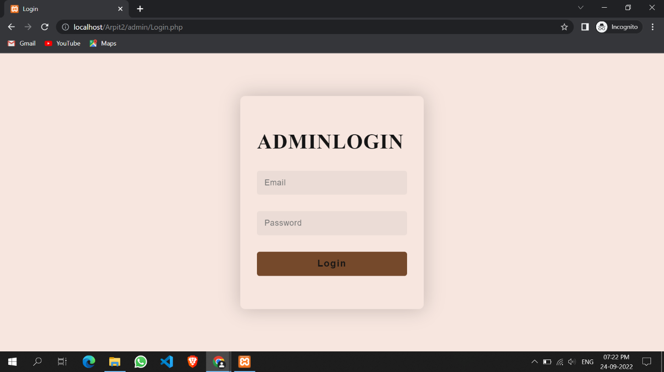
  7. **Admin Dashboard:**
  8. 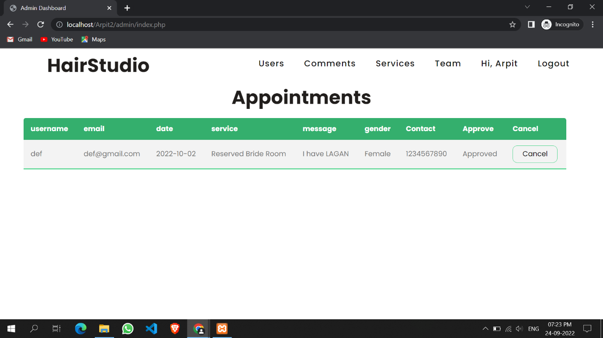
  9. **Admin View User:**
  10. 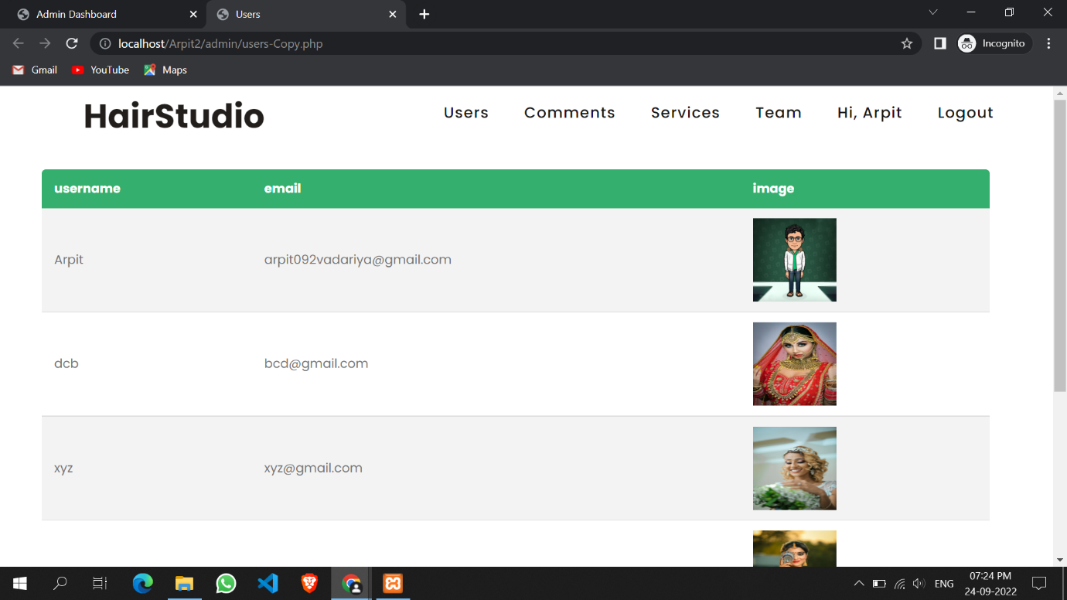
  11. **Admin View Comment:**
  12. 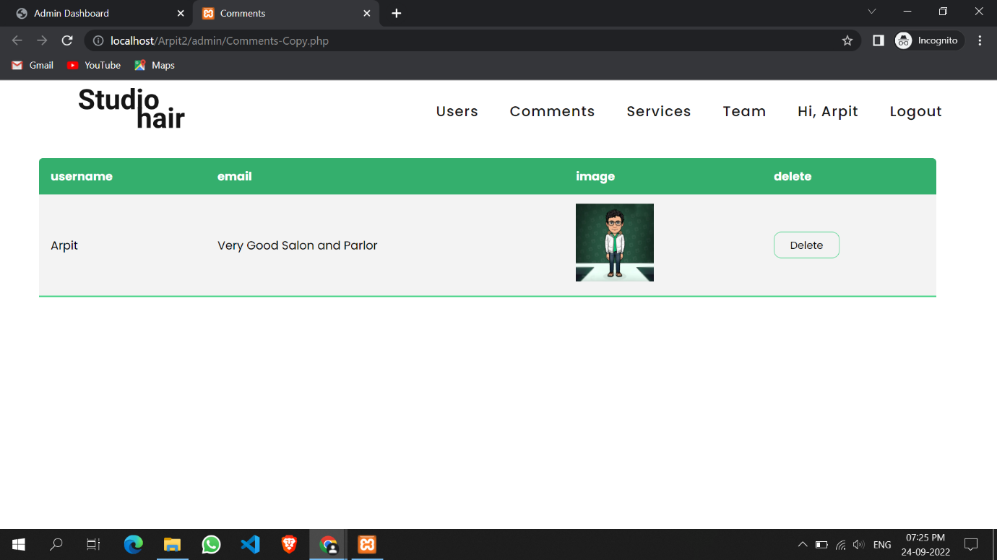
  13. **Admin Services:**
  14. 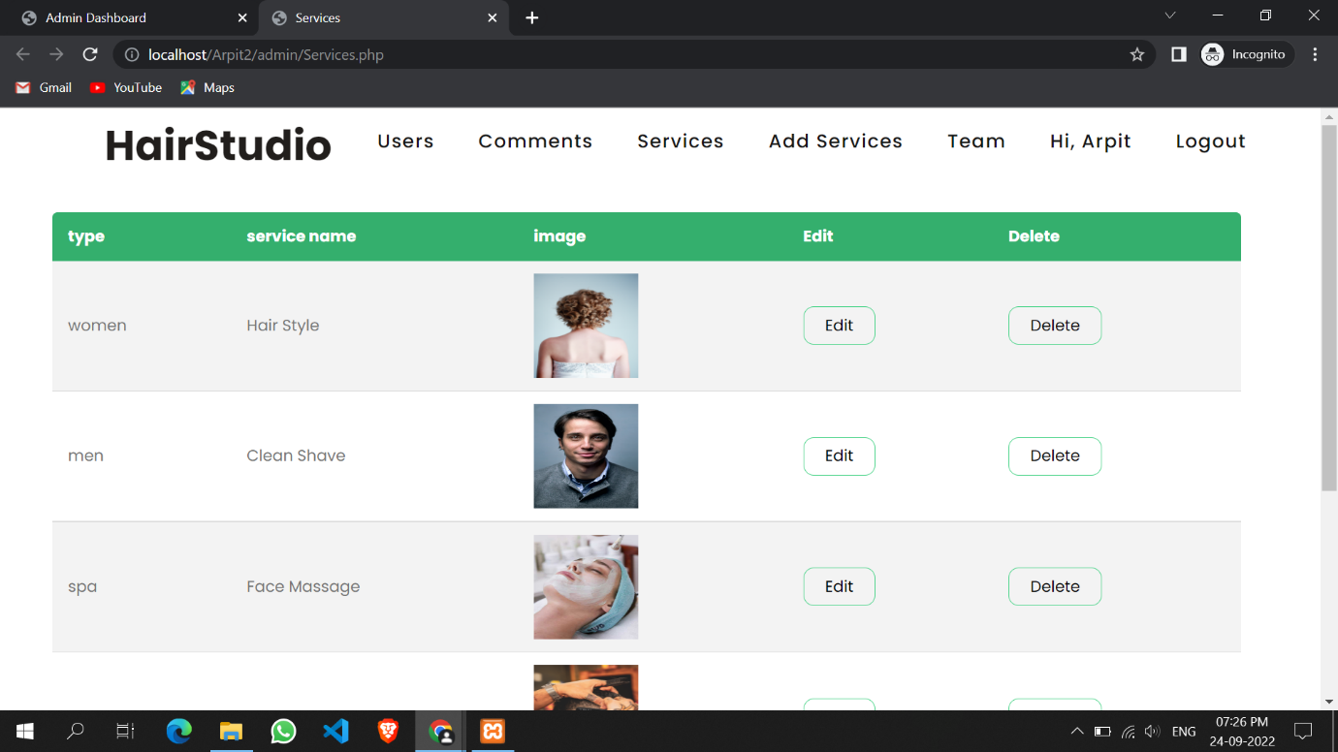
  15. **Admin add service:**

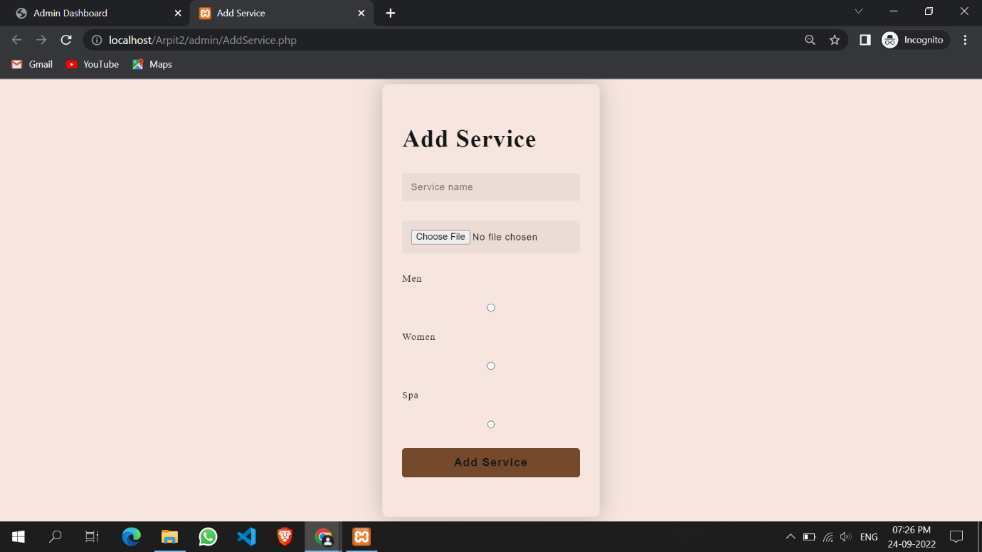

**Admin Team:**

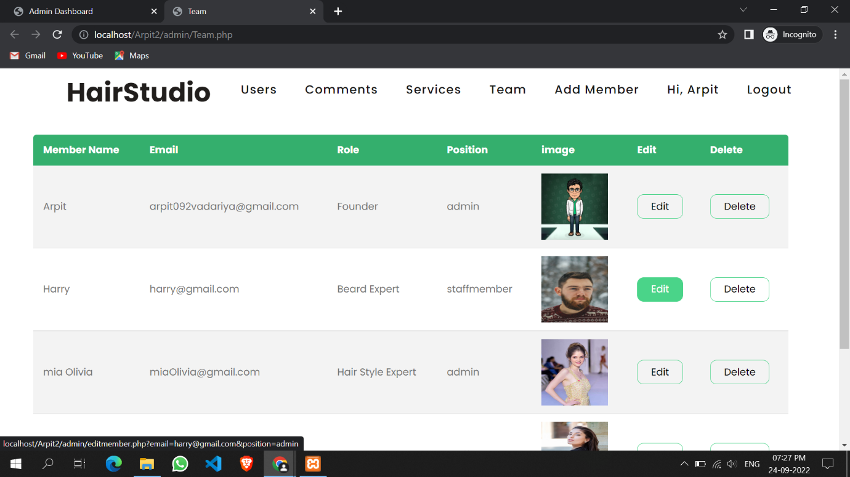

* 1. **Admin add team member:**
  2. 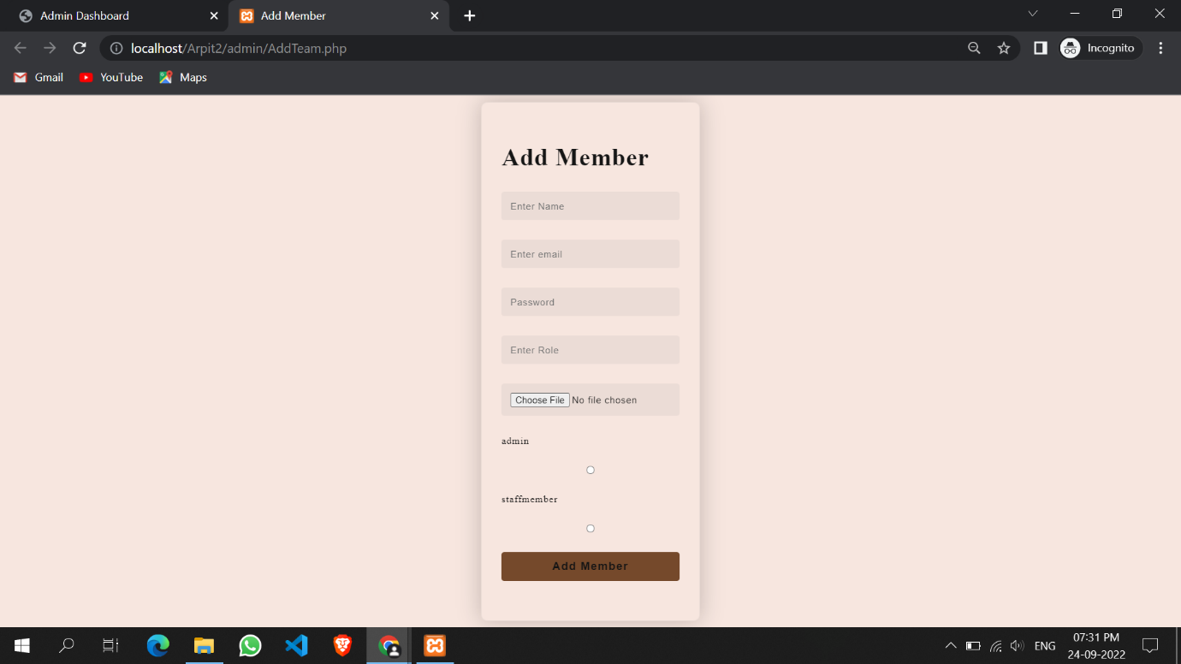
  3. **Admin Profile Page:**
  4. 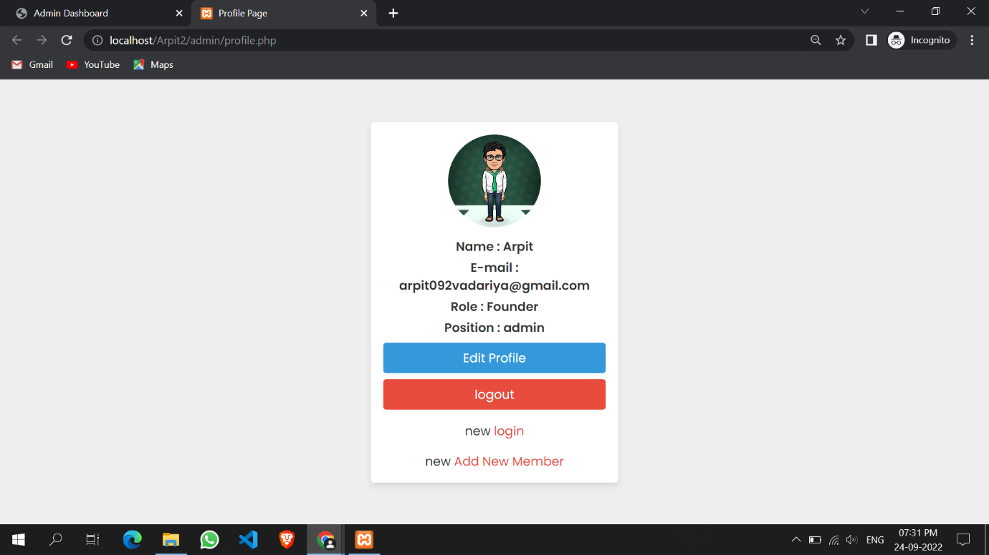
  5. **Admin Edit Profile:**
  6. 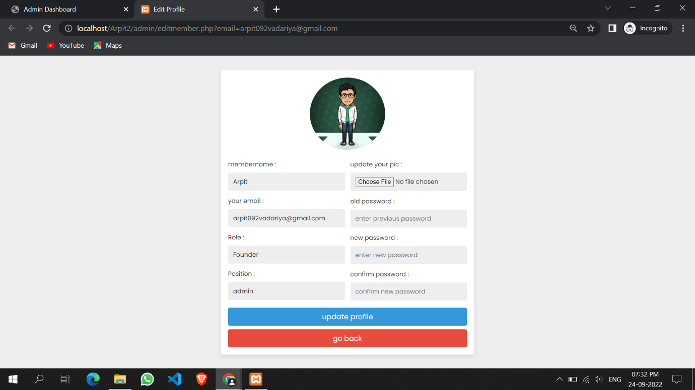

**5.3 Sample Code**

Here is the sample code of our project.

* Register Page

Register.php

<?php

include 'Config.php';

error_reporting(0);

session_start();

if (isset($_SESSION['username'])) {

header("Location: index.php");

}

if (isset($_POST['submit'])) {

$username = $_POST['username'];

$email = $_POST['email'];

$password = $_POST['password'];

$cpassword = $_POST['cpassword'];

$file = $_FILES['photo'];

// $password = md5($_POST['password']);

// $cpassword = md5($_POST['cpassword']);

// print_r($file);

$filename = $file['name'];

$filepath = $file['tmp_name'];

$fileerror = $file['error'];

if ($password == $cpassword) {

$sql = "SELECT * FROM userdata WHERE email='$email'";

$result = mysqli_query($conn, $sql);

if (!$result->num_rows > 0) {

if($fileerror == 0){

// only relative path changing most important most most imp

$destfile = '../Pages/Images/UserImage/'.$filename;

// echo "$destfile";

move_uploaded_file($filepath, $destfile);

// $insertquery = "INSERT INTO userdata (username, email, password, imagepath) VALUES ('$username', '$email', '$password', 'destfile')";

// $result = mysqli_query($conn, $insertquery);

$imginsert = "INSERT INTO userdata(username, email, password, imagepath) VALUES('$username', '$email', '$password', '$destfile')";

$imgresult = mysqli_query($conn, $imginsert);

if ($imgresult) {

echo "<script>alert('Wow! User Registration Completed.')</script>";

echo '<script> window.location.href="Login.php"; </script>';

// header("Location: Login.php");

$username = "";

$email = "";

$_POST['password'] = "";

$_POST['cpassword'] = "";

} else {

echo "<script>alert('Woops! Something Wrong Went.')</script>";

}

} else {

echo "<script>alert('Woops! Something Wrong Went in file.')</script>";

}

} else {

echo "<script>alert('Woops! Email Already Exists.')</script>";

}

} else {

echo "<script>alert('Password Not Matched.')</script>";

}

}

?>

<!DOCTYPE html>

<html>

<head>

<meta charset="utf-8">

<meta name="viewport" content="width=device-width, initial-scale=1.0">

<link rel="stylesheet" href="https://stackpath.bootstrapcdn.com/font-awesome/4.7.0/css/font-awesome.min.css">

<link rel="stylesheet" type="text/css" href="style.css">

<title>Register Form</title>

</head>

<body>

<section class="container">

<div class="login-container">

<div class="form-container">

<h1 class="opacity">REGISTER</h1>

<form action="" method="POST" class="login-email" enctype="multipart/form-data">

<div class="input-group">

<input type="text" placeholder="Username" name="username" value="" required>

</div>

<div class="input-group">

<input type="email" placeholder="Email" name="email" value="" required>

</div>

<div class="input-group">

<input type="password" placeholder="Password" name="password" value="" required>

</div>

<div class="input-group">

<input type="password" placeholder="Confirm Password" name="cpassword" value="" required>

</div>

<div class="input-group">

<input type="file" name="photo" placeholder="image" value="" required>

</div>

<div class="input-group">

<button name="submit" class="btn">Register</button>

</div>

<p class="login-register-text">Have an account? <a href="Login.php">Login Here</a>.</p>

</form>

</div>

</div>

</section>

</body>

</html>

* Login Page

Login.php

<?php

include 'Config.php';

session_start();

error_reporting(0);

if (isset($_SESSION['username'])) {

header("Location: ../Pages/index.php");

}

if (isset($_POST['submit'])) {

$email = $_POST['email'];

$password = $_POST['password'];

// $password = md5($_POST['password']);

$sql = "SELECT * FROM userdata WHERE email='$email' AND password='$password'";

$result = mysqli_query($conn, $sql);

if ($result->num_rows > 0) {

$row = mysqli_fetch_assoc($result);

$_SESSION['username'] = $row['username'];

$_SESSION['imagepath'] = $row['imagepath'];

$_SESSION['email'] = $row['email'];

echo "<script>alert('Login Successfull.')</script>";

echo '<script> window.location.href="../Pages/index.php"; </script>';

// header("Location: ../Pages/index.php");

} else {

echo "<script>alert('Woops! Email or Password is Wrong.')</script>";

}

}

?>

<!DOCTYPE html>

<html>

<head>

<meta charset="utf-8">

<meta name="viewport" content="width=device-width, initial-scale=1.0">

<!-- <link rel="stylesheet" href="https://stackpath.bootstrapcdn.com/font-awesome/4.7.0/css/font-awesome.min.css"> -->

<link rel="stylesheet" type="text/css" href="style.css">

<title>Login Form</title>

<link rel="stylesheet" href="style.css" />

</head>

<body>

<section class="container">

<div class="login-container">

<div class="form-container">

<h1 class="opacity">LOGIN</h1>

<form action="" method="POST" class="login-email">

<div class="input-group">

<input type="email" placeholder="Email" name="email" value="<?php echo $email; ?>" required>

</div>

<div class="input-group">

<input type="password" placeholder="Password" name="password" value="<?php echo $_POST['password']; ?>" required>

</div>

<div class="input-group">

<button name="submit" class="btn">Login</button>

</div>

<p class="login-register-text">Don't have an account? <a href="Register.php">Register Here</a>.</p>

</form>

</div>

</div>

</section>

</body>

</html>

* Index Page

index.php

<?php

include("Config.php");

?>

<!DOCTYPE html>

<html lang="en">

<head>

<?php include 'Links.php'; ?>

</head>

<title>Hair Studio</title>

<body>

<!-- Navigation Bar Start -->

<header class="header" id="header">

<?php include 'navbar.php'; ?>

</header>

<!-- Navigation Bar End -->

<!-- Header End -->

<!-- Carousel Start -->

<?php include 'Carousel.php'; ?>

<!-- Carousel End -->

<!-- Service Start -->

<?php include 'Services.php'; ?>

<!-- Service End -->

<!-- Bride Page Details Start -->

<!-- Bride Page Details End -->

<!-- Start Testimonial Section -->

<?php include 'Testimonial.php'; ?>

<!-- End Testimonial Section -->

<!-- About Section Start -->

<?php include 'About.php'; ?>

<!-- About Section End -->

<!-- Start Package Section -->

<?php include 'Package.php' ?>

<!-- End Package Section -->

<!-- Footer Section Start -->

<?php include 'footer.php'; ?>

<!-- Footer Section End -->

<!-- javascript files start -->

<?php include 'JSFile.php'; ?>

<!-- javascript files end -->

</body>

</html>

* Logout Page

Logout.php

<?php

session_start();

session_destroy();

header("Location: Login.php");

?>

**Testing**

Testing is the process of evaluating a system or application, to check whether the application meets all requirements of the client and to detect the errors.

Generally testing can be classified into static testing and dynamic testing.

Again Dynamic Testing is classified into two types: Structural Testing (or) white box, Functional Testing (or) Black Box testing.

**Static Testing**

Verification activities fall into the category of Static Testing. Static testing refers to testing something that’s not running. It is examining and reviewing it. i.e., to check whether the work done meets the standards of the organization. Reviews, Inspections and Walk-through are static testing methodologies.

Example: The specification is a document and not an executing program. When we read it to find out the issues, it is considered as static testing.

**Dynamic Testing**

Dynamic Testing involves working with the software, giving input values and checking if the output is as expected. These are the Validation activities. Unit Tests, Integration Tests, System Tests and Acceptance Tests are few of the Dynamic Testing methodologies.

Techniques used are determined by type of testing that must be conducted.

* Functional ("black box") testing.
* Structural (usually called "white box") testing.

Black box testing involves looking at the specifications and does not require examining the code of a program. Tests that examine the observable behavior of software as evidenced by its outputs without referencing to internal functions is black box testing. It is not based on any knowledge of internal design or code and tests are based on requirements and functionality. Nowadays there are automatic code generation tools and code re-use becomes more prevalent, analysis of source code itself becomes less important and functional tests become more important.

Black box testing is easy as it is based on system’s response for a given user’s input. If we know the business functionality of the product, we can do black box testing. On the other hand, white box testing requires programming knowledge to know the internals of the code. Also it is time consuming. So only a developer can become a white box tester\

**Black-Box** tests are used to demonstrate that:

* Software functions are operational.
* Input is properly accepted.
* Output is correctly produced.
* Integrity of external information (database) is maintained.

**White-Box** tests can be designed only after a component-level design (or source code) exists. The logical details of the program must be available. The status of the program is examined at various points to determine if the expected status corresponds with the actual status.

Internal program logic is tested using ‘White Box’ test case design techniques.

Using White-Box testing methods we can derive test cases that:

* Guarantee that all independent paths within a module have been exercised at least once.
* Execute all loops at their boundaries and within their operational bounds.

Exercise internal data structures to ensure their validity.

Chapter-6

**Limitations and Future**

**Enhancement**

**Limitation:**

* Online payment is not available.
* Mandatory sign-up needed for the client.
* Only read module for viewer or customer.
* Different rights for actors.

**Future Enhancement:**

* Payment method will be available.­­­­
* New customization in website.
* More modules will be updated.
* Bug fixes and performance.
* More attractive.

­­­­­­­­

Chapter-7

Bibliography

* **Reference Sites:**

<https://www.tutorialspoint.com/php/>

https://www. stackoverflow.com/

https://www. getbootstrap.com/

[htttp://www.youtube.com](http://www.youtube.com)/

[htttp://www.jquery.com](http://www.youtube.com)/

<https://www.thapatechnical.com/>

<https://www.w3schools.com/>

<https://www.geeksforgeeks.org/>